(Approx. 1836 words)

President's Corner
Bad Memories
Author: Greg Skalka, President, Under the Computer Hood UG, CA
September 2019 issue, Drive Light
www.uchug.org
president (at) uchug.org

We are our memories. Our personalities and identities are tied to the information stored in our brains. We are who we are due to our memories of experiences, remembered preferences and lessons learned over our lifetimes. Without our brain’s ability to store and retrieve memories, we could not learn, improve ourselves or differentiate ourselves from others as individuals.

Almost everything we do has to be learned, and thus remembered in some type of memory, and there are several types used by our brains. Some things, like the beating of our hearts or breathing, may not relate to memory, as we don’t have to learn these things. A lot of other physical things, from simple things like walking or picking up objects to more complex activities like riding a bike or speaking, require memory, as we must learn them, as opposed to being born with these capabilities. These are attributed to what we sometimes call “muscle memory", something we remember how to do but don’t consciously have to think about. We also appear to have a “scratchpad” short term memory, which can be used to store a small number of items (5 to 9) for a short time (maybe 15 to 30 seconds). This is what we use to remember a phone number read to us; without some reinforcement the information quickly bleeds away.

In more complex learning and in remembering experiences, the mind uses short term memory and then converts some short-term memories to long term. Long term memory is usually defined as memory lasting longer than 30 seconds, although long term memory of the last few days or years is also often referred to as short term memory. In some cases, injury or disease can affect memory, especially short-term memory. General aging, Alzheimer’s disease and other dementias, brain tumors, blood clots and infections around the brain, head injuries and substance abuse can all cause short term memory loss. A common situation in these cases is a person that can remember in great detail events and people from 20 years in their past but is unable to remember recent events or people known for a short time.

Amnesia is a form of memory loss where the subject retains their identity and basic motor skills such as walking and speech but loses some memories or the ability to form new memories. One very common type is infantile amnesia, in which you cannot remember the first three to five years of life. In retrograde amnesia, you lose previously created memories, typically starting with most recent ones. Diseases like Alzheimer’s gradually cause this type of amnesia. With anterograde amnesia, new memories cannot be formed. This can be a temporary condition, as in a black-out from excessive alcohol consumption, or permanent, when due to a brain injury. The 2000 movie “Memento” portrays anterograde amnesia.

A good friend recently told me about an incident he had not long-ago involving memory loss. He went to the gym after work one day as he was in the habit of doing, but he does not remember what he did there on that visit. His wife was called to the gym by the manager, out of concern that something was wrong with my friend. The manager said my friend was looking for his gym bag and had repeatedly asked for the manager. He had asked for the manager’s name several times during their interaction, even though the manager told it to him each time. Concerned that he’d had a stroke, my friend’s wife took him to the emergency room, where after extensive testing it was found he had experienced TGA, or transient global amnesia. For about an hour and a half, my friend’s brain made no short-term memories. Although he could otherwise function and knew where he was, he could not remember anything of his time at the gym or why he was there and was confused by it. He could remember his past and recognized his wife, but still has no recollection of events at the gym that day. It is not known what causes TGA, though it seldom results in a repeat incident.

I’ve since learned that another friend’s wife had a TGA incident about 20 years ago. Hearing about these incidents and the stories my sister has told about her mother-in-law’s Alzheimer’s makes me wish there were some way to back up our human memories. I guess the closest we can get to that now is to take lots of photos and videos of our lives.

Computers and other tech devices also rely on memories to function, and there are a number of parallels to humans in the way memories are used and the problems they have. There are different types of electronic digital memories, and they are used in computers in different ways.

The two main types of digital memory are volatile, which retain their information only as long as power is applied to them, and non-volatile, which retain their information even without power. Volatile memories include both types of RAM (random access memory): static (SRAM) and dynamic (DRAM). Non-volatile memories include Flash memory (USB Flash drives and solid-state drives or SSDs), magnetic hard drives, floppy disks and optical discs. Memory is located in many places in most computing devices, including small blocks of high-speed cache RAM inside the microprocessor component, fast DRAM modules for main memory, SSD modules or magnetic hard drives for main OS / program / data storage and peripheral removable storage (USB, floppy and optical discs).

Just as with humans, computers and tech devices without memories cannot function. It is the information stored as operating systems, apps and data in our tech devices that give them their “personalities” and capabilities. A computer or smart phone with blank memory devices is just an empty, inert shell.

Memory failures can cause big problems for computers, as they do for humans. An unreliable main memory DRAM module can result in errant program operation and computer crashes. SSD or hard drive failures can mean data loss, programs that won’t load and OS crashes.

Our electronic digital memories give us two advantages over our human memories - the ability to easily replace faulty components and the ability to back up our data, so faulty components don’t result in a serious loss. Important data in non-volatile memory devices should be backed up or copied to other devices, so that a failure of the original device can be easily corrected by replacing the device and restoring the data from the back-up copy. Bad volatile memories like DRAM modules can easily be replaced so computing can resume.

I got my first camera in grade school and have always enjoyed taking photos. I have taken quite a few over the years, and the quantity increased greatly once I got a digital camera and no longer had to worry about the cost in film and developing each shot represented. I now take thousands of digital photos and hours of digital video each year. It does provide that additional assist to my memory when I want to know when an event occurred, as I can check the date stamped on my slides or photo prints or the time/date stamp in my photo jpeg files.

Having digital photo files is great, as they don’t degrade and can be backed up, but over the years the file size of photos has greatly increased. My first digital camera was just 1 Megapixel, and the photo files were only about 100 KB each. My latest camera takes 18 Megapixel photos, resulting in 10 MB files each. Such large files make great photos, but they have become difficult to share, at least in their full-size form. These files are really too big to email as an attachment, and while I have often put them up on a file sharing site to allow others to download, some folks I send them to have problems getting them. Even for those tech savvy recipients, downloading 30 GB of data can be a pain.

My son was recently married, and I took a number of photos and videos of the event and days surrounding it that I wanted to share with relatives. I wound up with about 20 GB of data to share. Since this was a one-time event with files going to only about eight recipients, some of which were out of state, I decided the best way to share was to copy the files to relatively inexpensive USB flash memory devices and give them out in person or mail them.

All I needed was about ten 32 GB Flash drives, which could be had for around $8 each. I had previously bought some loose Patriot 32 GB drives from Amazon; these came in a cardboard envelope. I needed more, so I also bought some from Fry’s Electronics; I got 32 GB individually packaged Samsung drives for about the same price on sale.

Our group’s board meeting was just a few days after I bought the Fry’s drives, and so I told the board about my need for USB Flash drives and the purchases I’d made. Our vice president then warned me about buying Flash drives online, as the quality can sometimes be poor. He claimed that parts that fail manufacturing tests can be intercepted from the dumpsters and sold online as “good” drives. I thought that unlikely from Amazon, but I soon found our VP’s warning to be credible.

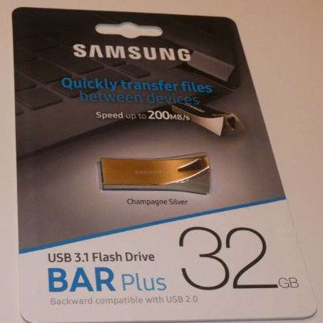
A few days after the board meeting, I started copying the files onto the USB Flash drives. I had used some of the Amazon drives and had only one left, and so started with it. During the copy process, however, it stopped and said the drive was full. I was only copying 20 GB onto a 32 GB drive, yet it had stopped with only about 4 GB put onto the drive. Windows File Explorer indicated the drive was 32 GB in size, but with only 4 GB on it, it said it had 27 GB of used space and 4 GB free. Something was definitely wrong with this drive. I recalled no problems with the others I’d bought in this Amazon batch, but also recalled that I had only put no more that 2-3 GB on any of them before giving them out.
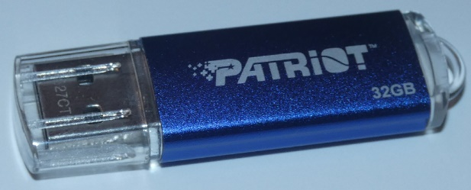

Bad Drive

Good Drive

I pulled out my Fry’s drives and all worked fine with the full 20 GB of files. I considered that it was possible that my Amazon drives could have been “counterfeits” pulled from the manufacturer’s dumpsters and resold; after all, they came in unconventional (meaning no) packaging. The Fry’s drives were shrink-wrapped onto cardboard holders, and so were more likely to have gone through the manufacturer’s full process.

It is unfortunate that the Fry’s drives are sold with additional packaging that winds up in the landfill, but it may be an additional indicator of an authentic, fully functional product.

